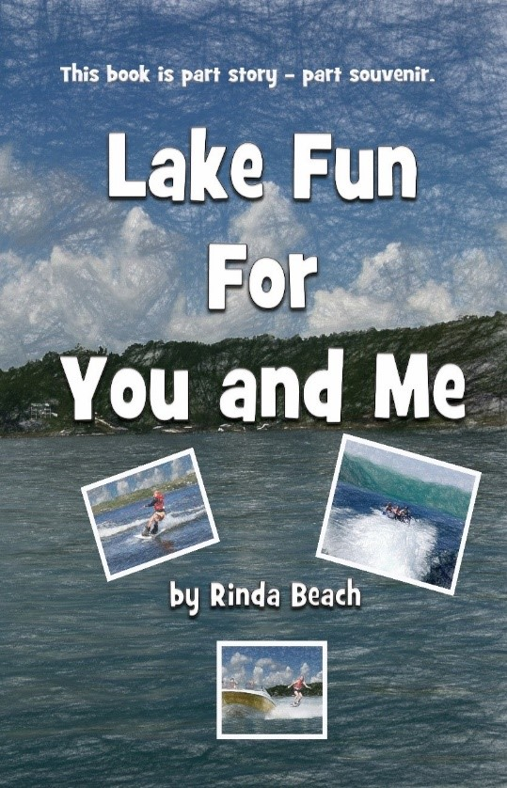
A Treasure Hunt – What can you find?
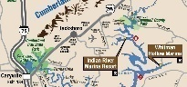
On a map?
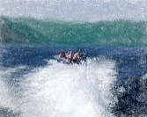

In the water?

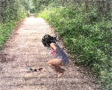
On land?

At a Marina?

Paperback $9.95 on Amazon Find me at rindbeach.com!

Directions: Fold this bookmark in half. Then glue it together. Less glue is better! If you want a short bookmark, cut it underneath the word ‘Paperback.’ If you want a long bookmark, cut it off above the word ‘Directions.’ Happy Reading!

