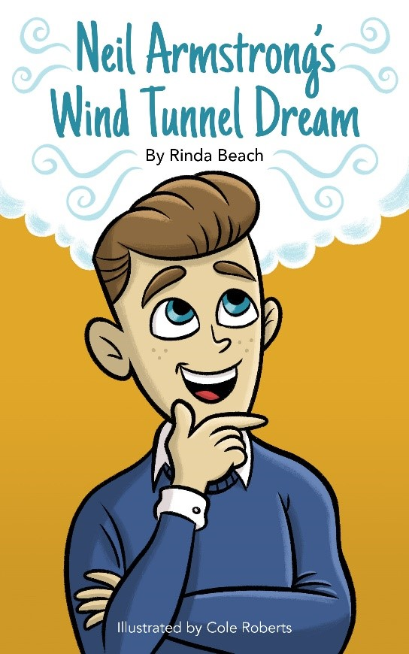
Follow young Neil as
he makes his dream
come true to build a
tunnel just like the Wright Brothers
Then build your own wind tunnel.

Meet Rinda Beach.
Author and publisher.
She’s lived in Wapak
since age 5. She was 10 when Neil
landed on the moon. Rinda met the
real wind tunnel by volunteering at
the museum. Look for her online
Paperback $7.99 Hardback $14.99 at rindabeach.com

Directions: Fold this bookmark in half. Then glue it together. Less glue is better! If you want a short bookmark, cut it underneath the word ‘Paperback.’ If you want a long bookmark, cut it off above the word ‘Directions.’ Happy Reading!

